1.8 I can store and retrieve files effectively, in line with guidelines and conventions where available

It is important to store files into folders that are easy to find and are labelled correctly.

Currently I have all my images, link buttons and thumbnails together but they should be separated for better organisation.

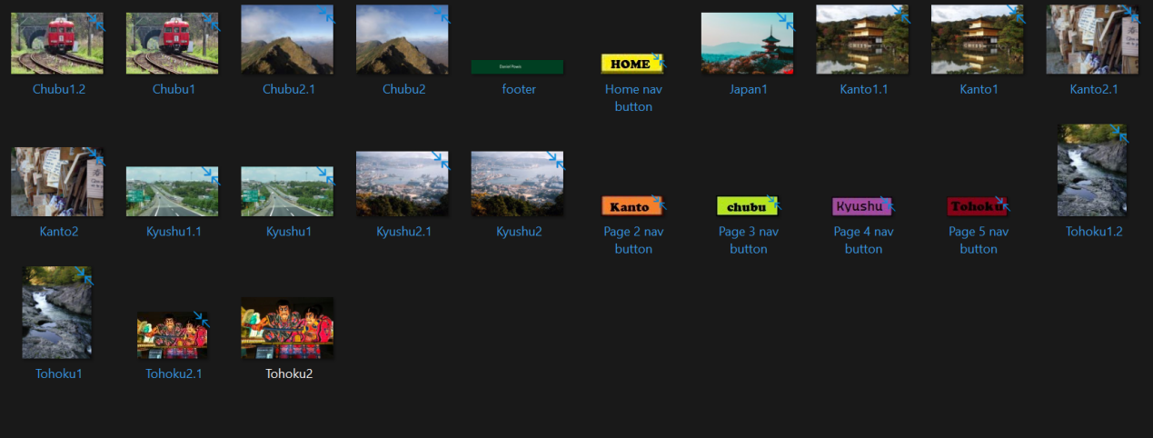

So I will create three separate folders for them to be stored.

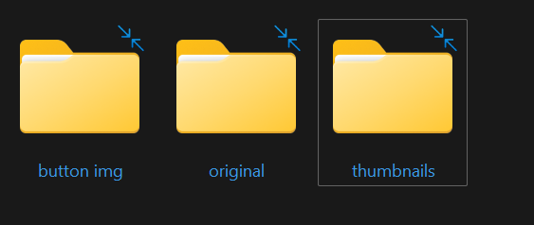

I also should put my website files into a separate folder to keep them all together.

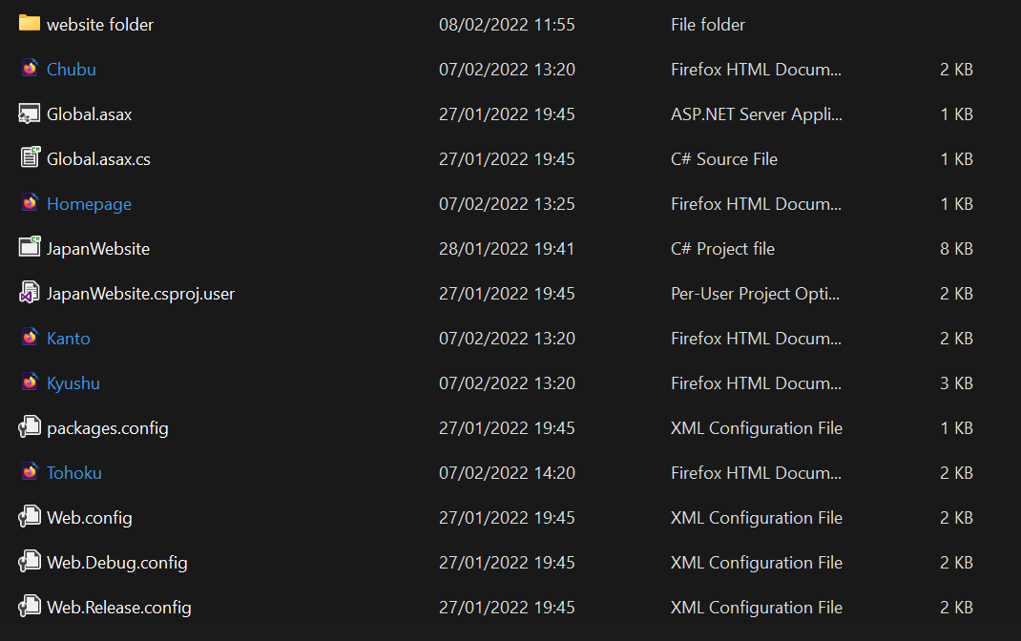

And this is the after.

